UWLSU Sports Access Fund
Engaging in sports and physical activity is not only an essential part of the university experience but also plays a vital role in promoting both physical and mental well-being. Recognising the financial challenges students face due to Cost of Living, UWLSU’s has introduced a Sport Access Fund to offer additional support.
The Sports Access Fund provides financial support for eligible students to participate in student-led sports at the University of West London Students' Union. This grant offers reimbursement for membership fees, covering the cost of joining sports groups.
Who is eligible
The Sports Access fund is designed to help enrolled UWL students who face financial barriers to participate fully in extracurricular activities. To qualify, you need to access one of the following bursaries or grants provided by the University of West London; or by any of the external funding organisations listed below.
This includes:
- You are receiving the Full-Time Undergraduate Bursary - for students whose household income is less than £28,000
- You are receiving Path to Success Bursary – for students who is enrolled in foundation year
- You are receiving the Reasonable Adjustment Fund – for students who receive financial support from UWL
- You have a refugee status
- You are an international student and a recipient of financial support from an external Trust or Charities (Find scholarships recognised by UWL here).
- You are already accessing Student Support fund (SSF) or Help to Achieve fund

You will be required to submit evidence to confirm you are receiving one of the above-mentioned scholarships/bursaries along with your application form when applying for this fund, this could be official letters or emails from the university or external organisation confirming it.

If you feel you need further help and support, UWL Student Advice can help with money advice and applying for extra funding. Please go to studenthub.uwl.ac.uk or email studentadvice@uwl.ac.uk to chat to a member of the team.

Application Process:
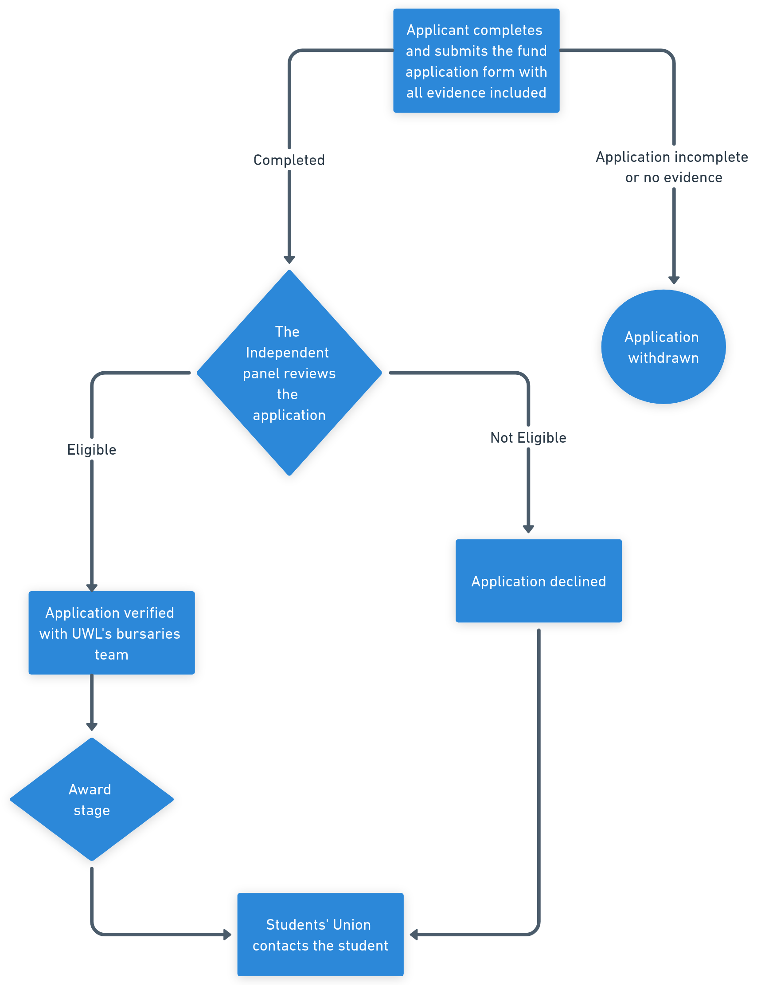

Application period
Open between 27th November 2024 to 6th of January 2025 for academic year 2024-25.

To find out more about the sports access fund please contact UWLSU on uwl.su@uwl.ac.uk

